HSE Monthly Report – June 2026
Weyland Energy – all sites
Hannah Weber · 09 July 2026 · HSE-RPT-2026-06

1. Headlines
High-potential near miss HSE-INC-2026-018 on 3 June: a 2.3 kg ratchet spanner fell about 22 m from the pile gripper frame on MV Sea Atlas and landed 2.5 m from a deck foreman. No injuries. Work stopped, safety stand-down on 4 June on all vessels, safety alert SA-2026-04 issued on 5 June. Investigation report issued 19 June.
Investigation of HSE-INC-2026-018 completed – see the investigation report in Incidents.

Indicator | June | YTD 2026 | 2025
Hours worked | 287,000 | 1,171,000 | 1,452,000
Lost time injuries | 0 | 1 | 2
Recordable injuries | 1 | 5 | 6
First aid cases | 8 | 30 | –
Near misses | 43 | 202 | 307
Safety observations | 381 | – | –
LTIFR rolling 12 months | 1.03 | – | 1.38
TRIR rolling 12 months | 4.66 | – | 4.13

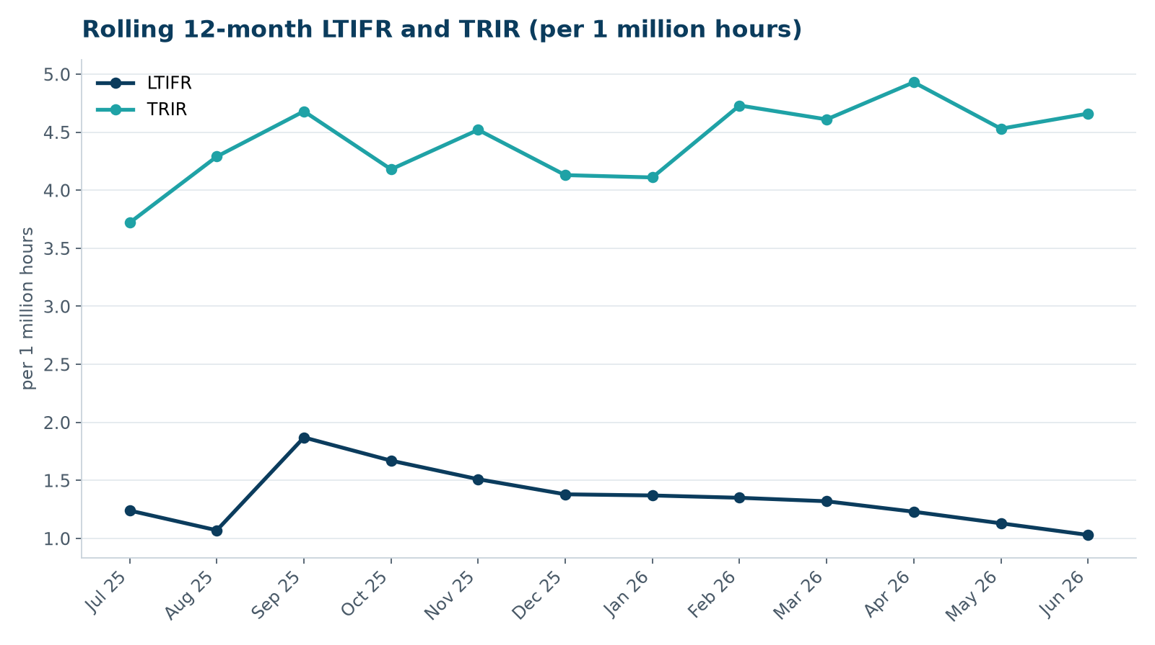

2. Hours by group
Group | Hours | Share
Weyland employees | 67,000 | 23 %
O&M contractors (operating assets) | 42,000 | 15 %
Harrow Bay contractors | 178,000 | 62 %

3. Leading indicators
- Toolbox talks delivered: 134
- Management safety walks: 15 (target 12)
- Inspections of lifting equipment: 65
- Open corrective actions older than 30 days: 4

4. Focus for next month
Heat stress awareness for nacelle work and solar park maintenance during summer.
Hannah Weber, HSE Manager

